**October 2024**

**Special Educational Needs and Disabilities**

**Information Report**



***We Learn, Grow, Shine in the Light of Jesus***



**St Leonard’s Catholic Primary School**

We learn, grow and shine in the Light of Jesus

**SPECIAL EDUCATIONAL NEEDS and DISABILITIES (SEND)**

**INFORMATION REPORT**

St Leonard’s Catholic Primary School's Information Report is written with due regard to the Special Educational Needs and Disability Act 2001 and the revised Code of Practice. St Leonard’s Catholic Primary School seeks to adhere to the principles of an inclusive education service as set out in the DfES/0774/2001 document on Inclusive schooling.

**Aims**

In St Leonard’s, we believe that every pupil, regardless of gender, race or disability, has a right to equal access to a broad and balanced curriculum. We consider it essential that the curriculum is presented in a supportive and stimulating atmosphere, which values each child and encourages him or her to achieve his or her full potential.

SEND provision within St Leonard’s Catholic School sits alongside other policies and information documents such as:

* School Admissions
* Anti-Bullying Policy
* Gender and Race Equality Policies
* Child Protection and Safeguarding Policy
* Code of Conduct
* Whistleblowing Policy
* Positive Behaviour for Learning Policy
* SEND Policy

**Introduction**

All Sunderland maintained schools have a similar approach to meeting the needs of pupils with Special Educational Needs and are supported by Together for Children Sunderland on behalf of Sunderland City Council to ensure that all pupils, regardless of their specific needs, make the best possible progress in school. All schools are supported to be as inclusive as possible, with the needs of pupils with Special Educational Needs and Disabilities being met in a mainstream setting wherever possible.

**What is the Local Offer?**

The LA Local Offer, The Children and Families Bill was enacted in 2014. From this date Local Authorities (LA) and schools are required to publish and keep under review information about services they expect to be available for children and young people with special educational needs (SEN) aged 0-25. This is the 'Local Offer'. Together for Children's Special Educational Needs (SEN) Team carries out statutory functions on behalf of Sunderland City Council in relation Education, Health and Care (EHC) needs assessments and Education Heath and Care Plans (EHCPs). The intention of the Local Offer is to improve choice and transparency for families. It will also be an important resource for parents in understanding the range of services and provision in the local area. The local offer can be accessed at:

[Local Offer | Sunderland Information Point](https://www.sunderlandinformationpoint.co.uk/kb5/sunderland/directory/localoffer.page?localofferchannel=0)

**The School Local Offer**

This utilises the LA Local Offer to meet the needs of SEND pupils as determined by school policy and the provision that the school is able to provide.

**The School Information Report**

This utilises the Together for Children Information Report to meet the needs of SEND pupils as determined by school policy and the provision that the school is able to provide.

**Key Personnel responsible for SEND at St Leonard’s Catholic Primary School are:**

**Headteacher: Mrs D Dunn**

**SENDCo Miss F McVittie**

**SEND Governor Dr C Emmerson**

All can be contacted at school on **0191 521 0300**

**Q1:**

**Who are the best people to talk to in this school about my child’s difficulties with learning/ Special Educational Needs or disability (SEND)?**

**The Class teacher - responsible for:**

* Checking on the progress of your child and identifying, planning and delivering any additional help your child may need (this could be things like targeted work, additional support) and letting the Special Education Needs/Disabilities Coordinator (SENDCo) know as necessary.
* Writing SEND Support plans, and sharing and reviewing these with parents at least twice per year and planning for the next plan. Personalised teaching and learning for your child as identified on school’s provision map.
* Ensuring that the school’s SEND Policy is followed in their classroom and for all the pupils they teach with any SEND.

**The SENDCo - responsible for:**

* Developing and reviewing the school’s SEND policy
* Coordinating all the support for children with special educational needs or disabilities (SEND)
* Ensuring that you are

1. Listened to and consulted
2. Involved in supporting your child’s learning

b) Kept informed about the support your child is receiving

c) Involved in reviewing the progress being made

* Liaising with all the other people who may be coming into to school to help support your child’s learning e.g. Speech and Language Therapy, Educational Psychology etc.
* Updating the school’s SEND register (a system for ensuring that all the SEND needs of pupils in this school are known) and making sure that records of your child’s progress and needs are kept.
* Providing specialist support for teachers and support staff in the school so that they can help children with SEND in the school to achieve the best progress possible.

**The Headteacher - responsible for:**

* The day to day management of all aspects of the school, this includes the support for children with SEND.
* The Headteacher will give responsibility to the SENDCo and class teachers, but is still responsible for ensuring that your child’s needs are met.
* The Headteacher must make sure that the Governing Body is kept up to date about issues relating to SEND.

**The SEND Governor - responsible for:**

* Making sure that the school has an up to date SEND Policy
* Making sure that the school has appropriate provision and has made necessary adaptations to meet the needs of all children in the school
* Making sure that the necessary support is made for any child who attends the school who has SEN and/or disabilities.
* Making visits to understand and monitor the support given to children with SEND in the school and being part of the process to ensure your child achieves his/her potential in school.

**Q2:**

**What are the different types of support available for children with SEND in our school?**

St Leonard’s Catholic Primary School aims to make appropriate provision for children recognised within the four broad areas of SEND need.

1. Communication and interaction, for e.g. autistic spectrum disorder, speech and language difficulties
2. Cognition and learning, for e.g. specific learning difficulties such as dyslexia, dyspraxia, dyscalculia
3. Social, emotional and mental health difficulties, for e.g. attention deficit hyperactivity disorder, anxiety disorder
4. Sensory and/ or physical needs, for e.g. visual impairments, hearing impairments, processing difficulties

Most children and young people will have their special educational needs met in mainstream schools through excellent classroom practice. This is called **Quality First Teaching.** At St Leonard’s we follow a graduated support approach which is called ‘Assess, Plan, Do, and Review’. This means that we will:

* **Assess** a child’s special educational needs
* **Plan** the provision to meet your child’s aspirations and agreed

outcomes

* **Do** put the provision in place to meet those outcomes
* **Review** the support and progress
* All our staff are trained to adapt lessons to the needs of the individual child so that every child is able to learn at their own pace and in their own way. We will make or provide additional resources as required.
* We use additional materials/ interventions so that we have something at the right level for children with SEND. Interventions are changeable and responsive to need.

1. **Class teacher input via excellent targeted classroom teaching (Quality First Teaching).**

For your child this would mean:

* That the class teacher has the highest possible expectations for your child and all pupils in their class.
* That all teaching is built on what your child already knows, can do and can understand.
* Different ways of teaching are in place so that your child is fully involved in learning in class. This may involve things like using more practical learning.
* Specific strategies (which may be suggested by the SENDCo) are in place to support your child to learn.
* Your child’s teacher will have carefully checked on your child’s progress and will have decided that your child has a gap or gaps in their understanding/learning and needs some extra support to help them make the best possible progress.
* Specific group work or Intervention which may be run in the classroom or outside by a teacher or a Teaching Assistant (TA).

1. **Specialist groups run by outside agencies** e.g .Speech and Language Therapy, Autism Outreach Team, Language and Learning, Behaviour Support Service, Sensory Team

***SEND Code of Practice 2014****:* ***School Support (SS)*** means a pupil has been identified by the SENDCo / class teacher as needing some extra specialist support in school from a professional outside the school. This may be from:

* Local Authority central services such as the ASD Outreach Team or Sensory Service (for students with a hearing or visual need)
* Outside agencies such as the Education Psychology Service (EPS).
* You may be asked to give your permission for the school to refer your child to a specialist professional e.g. Speech and Language Therapist or Educational Psychologist. This will help the school and yourself understand your child’s particular needs better and be able to support them better in school. The specialist professional will work with your child to understand their needs and make recommendations as to the ways your child is given support:

1. **Specified Individual support**

* This type of support is available for children whose learning needs are, severe, complex and lifelong.
* This is usually provided via ***an Education, Health and Care Plan (EHCP).*** This means your child will have been identified by professionals as needing a particularly high level of individual or small group teaching.
* This type of support is available for children with specific barriers to learning that cannot be overcome through Quality First Teaching and intervention groups (“Including All Children” documentation from LA).
* Your child will also need specialist support in school from a professional outside the school. This may be from:
* Local Authority central services such as the Autism Outreach Team or Sensory Service (for students with a hearing or visual need)
* Outside agencies such as the Speech and Language Therapy (SALT) Service
* For your child this would mean:
* The school can request that Local Authority Services carry out a statutory assessment of your child’s needs. This is a legal process which sets out the amount of support that will be provided for your child.
* After the request has been made to the ‘Panel of Professionals’ (with a lot of information about your child, including some from you), they will decide whether they think your child’s needs (as described in the paperwork provided), seem complex enough to need a statutory assessment. If this is the case they will ask you and all professionals involved with your child to write a report outlining your child’s needs. If they do not think your child needs this, they will ask the school to continue with the current support.
* After the reports have all been sent in, the ‘Panel of Professionals’ will decide if your child’s needs are severe, complex and lifelong. If this is the case they will write an Education Health Care Plan (EHCP). If this is not the case, they will ask the school to continue with the current level of support and also set up a meeting in school to ensure a plan is in place to ensure your child makes as much progress as possible.
* The EHC Plan will outline the number of hours of individual/small group support your child will receive from the LA and how the support should be used and what strategies must be put in place. It will also have long and short term goals for your child.
* An additional adult may be used to support your child with whole class learning, run individual programmes or run small groups including your child.

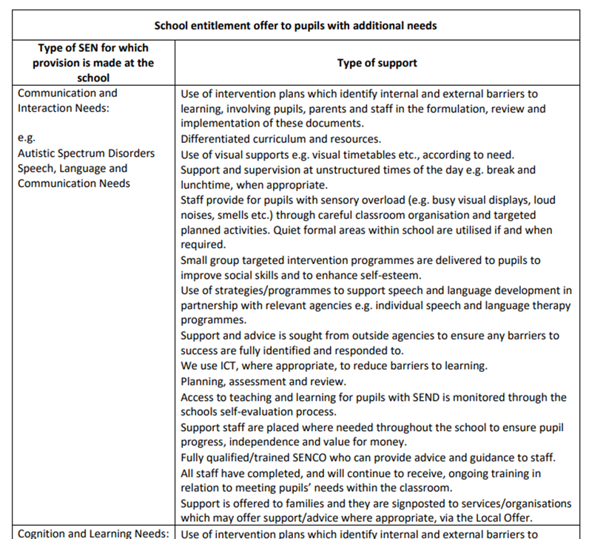

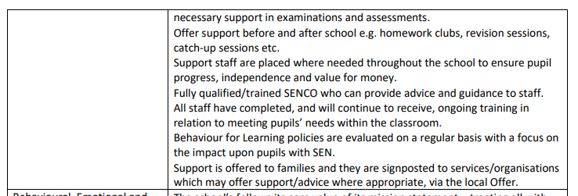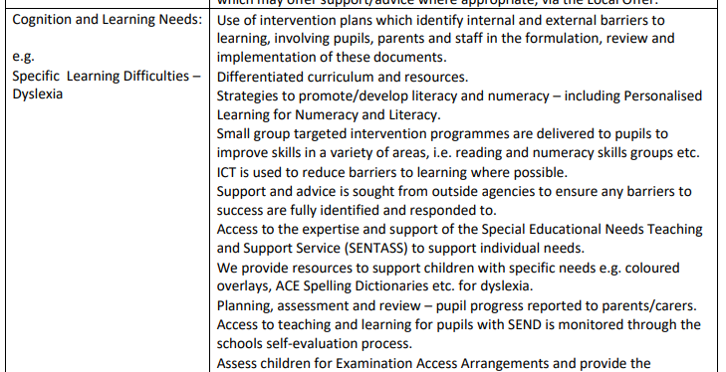

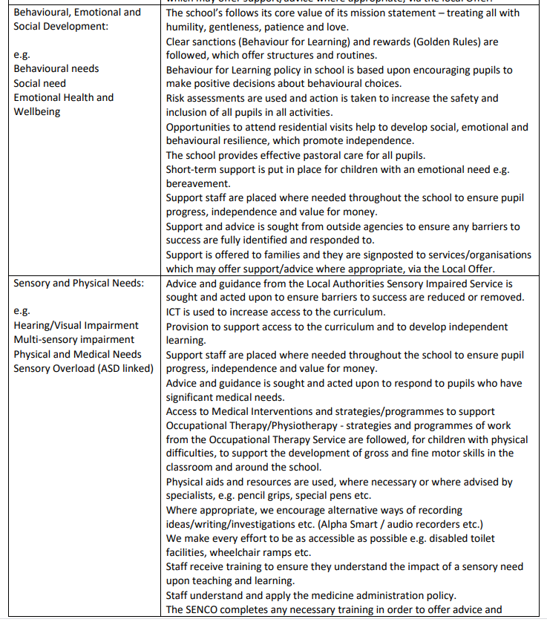

**Q3 : What are the SEND Ranges?**

St. Leonard’s uses the SEND Ranges, in line with Local Authority policy, to identify children’s needs. This document came into place on 1st September 2019. It is based on the graduated response of assess, plan, do review and the 4 areas of the SEND Code of Practice, 2014/2015. The broad areas of SEND are difficulties in the areas of:

1. Cognition and Learning

2. Communication & Interaction: ASD

Communication & Interaction: Speech, Language & Communication

3. Sensory and/or Physical (Hearing impairments, visual impairment, dual sensory, physical & medical)

4. Social, Emotional and Mental Health

It allows professionals to determine the level of need of each child with SEND. Children’s needs are attributed a numerical value from 1-7 and range from mild to profound. For example:

* Range 1 Mild
* Range 2 Mild-moderate
* Range 3 Moderate
* Range 4 (4a, 4b) Significant
* Range 5 Severe
* Range 6 Profound
* Range 7 Highly Specialist

In some cases, pupils will fall into more than one range, or will have needs in more than one area. The school staff (class teacher alongside the SENDCo) will study the ranges and highlight where there is greatest need. This may change in time and as the pupil matures. There will be specific times such as transition where the needs may change because of the differing environments and expectations. The ranges are a guide and provide a framework for the evidence that will be required.

* Once the range has been established, school professionals will find advice about how to support the learning of pupils at each range.
* It is important to recognise that Quality First Teaching will provide a firm basis upon which to use the additional strategies identified at each range. Strategies and advice from earlier ranges need to be utilised alongside more specialised information as the ranges increase.
* Specialist health interventions may be required at any level and this is an indicative framework as to how health resources may be deployed.
* Parents should seek further information required about the SEND Ranges from either the class teacher or the school SENDCO.

**Q4 : How can I let the school know I am concerned about my child’s progress in school?**

* If you have concerns about your child’s progress you should speak to your child’s class teacher initially.
* If you continue to be concerned that your child is not making progress, you may speak to the Special Education Needs/ Disabilities Coordinator (SENDCo).
* The school SEND Governor can also be contacted for support.

**Q5: How will St Leonard’s let me know if they have any concerns about my child’s learning in school?**

If your child is identified as not making progress, school staff, (class teacher and/ or SENDCo) will discuss this with you in more detail. School staff will:

* Listen to any concerns you may have
* Plan any additional support your child may need
* Discuss with you any referrals to outside professionals to support your child’s learning.
* If necessary, prepare a special educational needs plan with specific targets
* Provide feedback on the progress made by your child.

**Q6. How is extra support allocated to children and how do they progress in their learning?**

* The school budget, received from Sunderland Local Authority, includes money for supporting children with SEND. This is determined on the basis of needs in the school.
* The Head Teacher decides on the deployment of resources for Special Educational Needs and Disabilities in consultation with Bishop Chadwick Trust, the board of directors and the school governors.
* The Head Teacher and the SENDCo discuss all the information they have about SEND in the school, including the children getting extra support already, other children needing extra support and the children who have been identified as not making as much progress as would be expected. They then decide what resources/training and support is needed.
* We recognise that parents are the first providers of learning for their children and understand their difficulties the best. We will discuss with you and your child any challenges you feel exist and work together to find solutions to overcome the concerns.
* We will ask your child for their views on how they would like to be supported. These views are collated together onto a document called a One Page Profile.
* As a school we will set the highest possible expectations for your child, aiming to build skills that will support them throughout their life as future citizens of our community.
* Our teaching builds on what your child already knows, can do and can understand, and provides appropriate support to meet new learning challenges in a broad based curriculum
* Different ways of teaching are used so that your child is fully involved in learning in class. This may involve things like using more practical learning.
* Specific strategies (which may be suggested by the SENDCo) are in place to support your child to learn.
* Your child’s teacher will have carefully checked on your child’s progress and will have decided that your child has a gap or gaps in their understanding/learning and needs some extra support to help them make the best possible progress.
* Provision is made so that whenever possible SEND children access a broad range of learning experiences alongside their peers. This includes opportunities for extracurricular activities during and after the school day

**Q7: Who are the other people providing services to children with SEND in this school?**

**School provision**

* Teachers are responsible for leading learning for SEND groups, or individuals.
* Teaching Assistants mainly supporting learning in the classroom with either individual children or small groups.
* Teaching Assistants may lead learning outside of the classroom in an alternative room.

**Local Authority Provision delivered in school**

* Examples include:
* Autism Outreach Service
* Behaviour Support Service
* Language and Learning
* Parent Partnership Service
* Sensory Service for children with visual or hearing needs

**Health Provision delivered in school**

* Additional Speech and Language Therapy input to provide a higher level of service to the school.
* School Nurse
* Occupational Therapy
* Physiotherapy
* CAMHs
* CYPS

**Q8: How are the teachers in school helped to work with children with SEND and what training do they have?**

* We recognise that parents are the first providers of learning for their children and understand their difficulties the best.
* We will discuss with you and your child any challenges you feel exist and work together to find solutions to overcome the concerns.
* The SENDCOs job is to support the class teacher in planning for children with SEND.
* The school provides training and support to enable all staff to improve the teaching and learning of children, including those with SEND. This includes whole school training on SEND issues such as supporting students with a diagnosis of Autism, specific learning difficulties such as dyslexia and dyspraxia and Speech and language difficulties.
* The school works closely with the Director of SEND for Bishop Chadwick Trust.
* Individual teachers and support staff attend training courses run by outside agencies that are relevant to the needs of specific children in their class e.g. from the Autism Outreach Team (AOT) service.
* Miss McVittie has achieved the SENDCO national qualification.
* Miss Newcombe has completed the SENDCO national qualification.
* Our teaching builds on what your child already knows, can do and can understand, and provides appropriate support to meet new learning challenges in a broad based curriculum
* Different ways of teaching are used so that your child is fully involved in learning in class. This may involve things like using more practical learning, or specific strategies suggested to us by other specialists

**Q9: How will the teaching be adapted for my child with SEND?**

* Class Teachers plan lessons according to the specific needs of all groups of children in their class, and will ensure that your child’s needs are met.
* Support staff, under the direction of the class teacher, can adapt planning to support the needs of your child where necessary.
* Specific resources and strategies will be used to support your child individually and in groups.
* Planning and teaching will be adapted on a daily basis if needed to meet your child’s learning needs.

**Q10: How will we measure the progress of your child in school?**

* Your child’s progress is continually monitored by his/her class teacher.
* His/her progress is reviewed formally every term in Reading, Writing and Maths.
* At the end of each key stage 2 all children are required to be formally assessed using Standard Assessment Tests (SATS). This is something the government requires all schools to do and are the results that are published nationally.
* Children may have a Support Plan which will be reviewed, and a future plan made.
* We undertake termly assessments in Reading, Writing and Maths and use a number of resources to help teachers make accurate judgements.
* All teachers assess children’s learning day to day

The progress of children with an EHC Plan is formally reviewed at an Annual Review, with all adults involved with the child’s education.

**Q11: What support do we have for you as a parent of a child with a SEND?**

* The class teacher is regularly available to discuss your child’s progress or any concerns you may have and to share information about what is working well at home and school so similar strategies can be used.
* The SENDCo is available to meet with you to discuss your child’s progress or any concerns/worries you may have.
* All information from outside professionals will be discussed with you with the person involved directly, or where this is not possible, in a report.
* Support Plans may be reviewed with your involvement*.*
* Homework will be adjusted as needed to your child’s individual needs.
* A home/school contact book may be used to support communication with you, when this has been agreed to be useful for you and your child.

**Q12: How is St Leonard’s Catholic Primary School accessible to children with SEND?**

* The building is accessible via a ramp at the front of the building.
* We ensure, where ever possible, that equipment used is accessible to all children regardless of their needs.
* After school provision is accessible to all children including those with SEND.
* Extracurricular activities are accessible for children with SEND
* The school is on one level with some adapted access including ramps.
* The front desk has a wheel chair height section and hearing loop facility.
* There is an accessible toilet.
* All children are encouraged to have access to the full curriculum, with any appropriate adaptations and reasonable adjustments made.
* We ensure, where ever possible, that equipment used is accessible to all children regardless of their needs, with any reasonable adaptations made.
* Access to medical interventions will be supported on an individual basis, with an appropriate Care Plan and Risk Assessment audits and planning.
* Extra-curricular activities are accessible for children with SEND.
* Before school (Breakfast Club) and after school activities is accessible to all children including those with SEND in discussion with the independent provider.
* We will discuss with you and your child any challenges you feel exist and work together to find solutions to overcome the concerns. When possible, we will ask your child for their views on how they would like to be supported.

**Q13:**

**How are you supported to apply for a school place if your child has an Education, Health and Care Plan?**

We are committed to meeting the needs of all children including those with Special Educational Needs and Disabilities. We liaise with parents/carers and previous education providers prior to the pupil starting St Leonard’s Catholic Primary School, in order to discuss the identified needs, allowing for the planning and implementation of appropriate intervention. Advice from the LA or other agencies may be requested to ensure any the school can meet any needs appropriately.

Children and young people with an Education, Health and Care Plan follow a different admission and transfer process for a new school.  Please either apply online or request an application form to ensure that the Local Authority is aware of your school preference. You continue to have a right to request a particular school and this will be considered alongside the information that we have about your child’s special educational needs.  The information would have been provided as part of the Education, Health and Care assessment or following the review meeting.

**Q14. How will we support your child when they are leaving this school or moving on to another class?**

We recognise that transitions can be difficult for a child with SEND and take steps to ensure that any transition is a smooth as possible.

1. **If your child is moving to another school:**

* We will contact the school SENDCO and ensure he/she knows about any special arrangements or support that need to be made for your child.
* We will make sure that all records about your child are passed on as soon as possible.

1. **When moving classes in school:**

* Information will be passed on to the new class teacher in advance and a planning meeting will take place with the new teacher. Support Plans will be shared with the new teacher.
* If your child would be helped by a book to support them understand moving on then it will be made for them.

1. **In Year 6:**

* The school SENDCO will discuss the specific needs of your child with the SENDCO of their secondary school.
* Your child will do focused learning about aspects of transition to support their understanding of the changes ahead.
* Where possible your child will visit their new school on several occasions and in some cases staff from the new school will visit your child in this school.

**Q15:  
What Emotional and Social Development support we have for a child with a SEND?**

* We recognise that pupils with SEND may well have Emotional and Social Development needs that will require support in school.
* We recognise that parents are the first providers of learning for their children and understand their difficulties the best.
* We will discuss with you and your child any challenges you feel exist and work together to find solutions to overcome the concerns.
* The Emotional Health and Wellbeing of all our pupils is very important to us and we priortise this in terms of support given
* School staff are able to work with individual children, or groups to develop social skills.
* We have a robust Safeguarding Policy in place; we follow National Guidelines.
* We have a robust Positive Behaviour Policy in place.
* The Head teacher, Deputy Head teacher and all staff continually monitor the Emotional Health and Wellbeing of all our pupils.
* We have lunchtime groups for pupils who require extra support.
* We have links with other more specialist services which can offer advice and support, for e.g. Behaviour Support Service, CAMHS and CYPS
* When possible we will ask your child for their views on how they would like to be supported to develop social interaction skills.

**Q16**

**How can give feedback?**

**Compliments and Complaints**

Compliments are always greatly received and can be passed on either directly to staff and the SENDCo, or formally recorded via any questionnaires to parents/carers or in the form of a letter to the Head Teacher.

We hope that complaints about our SEND provision will be rare, however, if there should be a concern the process outlined in the school Complaints Policy should be followed.

Sunderland Special Educational Needs and Disability Information Advice and Support Service (SENDIASS) are also able to assist parents/carers of children with special educational needs. [sendiass@sunderlandcarers.co.uk](mailto:sendiass@sunderlandcarers.co.uk)

If the concern is directly related to decisions around an EHC Assessment or EHCP this will be managed directly by the Sunderland SEND Team.

**Feedback**

We are always seeking to improve the quality of education we provide for children with SEND and are keen to hear from parents/carer about their child’s experience.

**Additional Help**

Further information is available using the Sunderland local offer page:

<https://www.sunderlandinformationpoint.co.uk>

**Q17:  
Which policies do we use to identify and support SEND children in our school?**

* To follow requirements and guidance in the Educational Needs and Disability Code of Practice: 0-25 (DfE 2014)
* To follow outcomes from the Children’s and Families Act 2014 (Part 3)
* The regulations associated with Special Educational Needs and Disability Regulations 2014.
* The Special Educational Needs (personal Budgets and Direct Payments) Regulations, Section 49
* The Equality Act 2010.
* Special Educational Needs & Disability
* Disability Equality Policy
* Equal Opportunities
* Race Equality

|  |  |
| --- | --- |
| GLOSSARY OF TERMS | |
| SP | Support Plan |
| SEND Code of Practice | The legal document that sets out the requirements for SEND |
| EHCP | Education, Health, Care Plan |
| SEN | Special Educational Needs |
| SEND | Special Educational Needs and or Disabilities |
| SALT | Speech and Language Therapist |
| CAMHS | Child & Adolescent Mental Health Service |
| EP | Educational Psychologist |
| SENCDO | Special Educational Needs Disabilities Coordinator |